



Benefits of

Learning a

Language





MIDDLEBURY

INTERACTIVE LANGUAGES

World language learning for our middle school students

**Students at Caesar Rodney Middle Schools are participating in an exciting online world language program—Middlebury Interactive Fluency Courses in Spanish and Chinese.**

**Middlebury Interactive Fluency Courses bring the renowned Middlebury College language immersion experience to middle school students, online. Every aspect of our Fluency courses is designed around the idea of increasing the amount of time that students spend in-language!**

* ***Courses created by an international team of highly qualified language experts***
* ***Curriculum designed to meet ACTFL standards***
* ***Activities provide extensive exposure to authentic language use and multiple chances to truly use world languages, instead of merely memorizing vocabulary and grammar***
* Improved critical thinking, creativity, flexibility, and problem solving skills
* Improved SAT/ACT scores in both math and language arts
* Improved verbal skills in English as well as the target language
* Language study is viewed favorably by college admissions staff
* Research indicates that students who took foreign language courses gained acceptance to larger and better institutions than those who did not

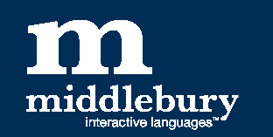

**PARENT TIPS**

*For supporting language learning at home*

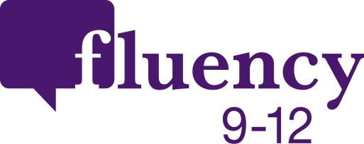

**Learn Together**—log onto the course with your child and practice activities together

**Experience the Culture**—watch a movie, dine at a restaurant, follow news and events

**Monitor Progress**—access your child’s online grade book and praise progress